GEF-6 REQUEST FOR chemicals and wastes enabling activity
Proposal for Funding Under the GEF Trust Fund
For more information about GEF, visit TheGEF.org

part i: project IDentifiers
Project Title: | Development of National Action Plan for Artisanal and Small Scale Gold Mining in Mongolia
Country(ies): | Mongolia | GEF Project ID:
GEF Agency(ies): | UNEP | GEF Agency Project ID: | 01434
Other Executing Partner(s): | Ministry of Environment, Green Development and Tourism of Mongolia (MEGDT) | Submission Date: | June 27, 2016
GEF Focal Area (s): | Chemicals and Wastes | Project Duration (Months) | 24
Type of Report: | NAP | Expected Report Submission to Convention | 24 months after receipt of the first cash advance by participating countries.

Project Framework*

Project outcome: Mongolia has developed and submitted a NAP in compliance with Annex C of the Minamata Convention to guide its future action in reducing mercury emissions and releases from, artisanal and small-scale gold mining and processing.

Project objective: To protect human health and the environment from the risks posed by the emissions and releases to the environment of mercury from artisanal and small-scale gold mining and processing in Mongolia by developing a NAP in compliance with Annex C of the Minamata Convention.
Project Component | Project Outputs | (in $)
Project Component | Project Outputs | GEF Project  Financing | Confirmed Co-financing
Global Technical Support for NAP development | - Training and guidance provided to relevant national stakeholders in Mongolia to develop and implement a NAP as per Annex C of the Minamata Convention  - Draft NAP developed as per Annex C of the Minamata Convention | 389,292 | 0
Endorsement and submission of the National Action Plan to the Minamata Secretariat | - Technical support provided to Mongolia to facilitate the NAP endorsement and submission to the Minamata Secretariat. | 40,300 | 0
Monitoring and Evaluation |  | 25,000
Subtotal |  | 454,592 | 0
Project Management Cost |  | 45,408 | 0
Total Project Cost |  | 500,000 | 0
* List the $ by project components. Please attach a detailed project budget table that supports all the project components in this table.

- Source of Co-financing for the Project by Name and by Type
Sources of Co-financing | Name of Co-financier | Type of Co-financing | Amount ($)
NA |  |  | 0
Total Co-financing |  |  | 0

- GEF Financing Resources Requested by Agency, Country and Programming of Funds
GEF Agency | Trust Fund | Country/  Regional/ Global | Focal Area | Programming  of Funds | (in $)
 |  |  |  |  | GEF Project Financing (a) | Agency Fee (b)^{b)} | Total  (c)=a+b
UNEP | GEFTF | Mongolia | Chemicals and Wastes | Mercury | 500,000 | 47,500 | 547,500
Total GEF Resources |  |  |  |  | 500,000 | 47,500 | 547,500
a) Refer to the Fee Policy for GEF Partner Agencies

part ii: Enabling Activity JustiFication

- Enabling Activity Background and Context

The Mercury Convention was adopted in January 2013 and will come into force once the required number of countries ratifies the Convention. The Minamata Convention on Mercury identifies and describes in its Article 13 the financial mechanism to support Parties from developing countries and countries with economies in transition to implement the Convention. It identifies two entities that will function as the Financial Mechanism: a) the Global Environment Facility Trust Fund; and b) A specific international Programme to support capacity-building and technical assistance. As such, the GEF Assembly, at its fifth meeting, held in May 2014, agreed to an allocation in its sixth replenishment of $141 million for work under the Convention, out of which $30 million to support enabling activities and promote their integration into national budgets and planning processes, national and sector policies and actions and global monitoring.

The revised GEF initial guidelines for enabling activities for the Minamata Convention on Mercury circulated to the GEF Council members in January 2014 presented in its section 2 the guidelines for the preparation of Artisanal and Small-Scale Gold Mining (ASGM) National Action Plans (NAPs) required under article 7. These guidelines were revised by the Intergovernmental Negotiating Committee 6 (INC 6) consistent with the resolution adopted by the Conference of Plenipotentiaries on the Minamata Convention on Mercury. The draft guidance was introduced to the INC 7 as an annex of the document UNEP(DTIE)/Hg/INC.7/17. It was agreed that the guidance in its current form would be used to assist countries in the preparation of their action plans in the period between the current session and the first meeting of the Conference of Parties. This project follows the guidelines introduced in the INC 7 and will seek for comments from Governments to improve the guidance with a view to presenting a revised version of it for consideration and possible adoption by the Conference of the Parties at its first meeting.

The project also contributes to the achievement of the expected accomplishment A under the UNEP biennial Programme of Work (PoW) 2016-2017 “countries increasingly have the necessary institutional capacity and policy instruments to manage chemicals and waste soundly, including the implementation of related provisions in the multilateral environmental agreements” . More precisely, the project contributes to the PoW output 2 “secretariat support provided to the intergovernmental negotiating committee to prepare a global legally binding instrument on mercury (the Minamata Convention on Mercury) during the interim period, prior to its entry into force”. Through this project UNEP will provide national stakeholders with the policy and technical instruments needed to develop the National Action Plan and will strengthen the national institutional capacity to its early implementation. It will also apply and comment the NAP guidance as required by the INC 7. The outcomes of this project are also aligned with the objectives of the proposed PoW and budget for the biennium 2018-2019 approved by UNEA in 2016, expected accomplishment A, policies and legal, institutional and fiscal strategies and mechanisms for sound chemicals management developed or implemented in countries within the framework of relevant multilateral environmental agreements and the Strategic Approach to International Chemicals Management (SAICM). The project will contribute to the indicator of achievement by increasing the number of countries that have used UNEP guidance in developing an Action Plan that promotes sound mercury management and implement the Minamata Convention.

Mongolia signed the Convention on 10 October 2013 and ratified on 18 September 2015. On 7 March 2016, Mongolia declared ASGM more than insignificant. Mongolia will benefit from new and updated information about the use of mercury and past policy approaches that have been successes and failures in formalizing and improving the environmental performance of the ASGM sector in each country, and from increased capacity in managing the risks of mercury emitted and released from such activity. The sharing of experiences and lessons learned throughout the project with other countries working on their NAPs is also expected to be an important contribution to other similar countries and foster cooperation for future implementation of the NAPs.

SDGs in Mongolia

The NAP development and future implementation contribute to achieve the following Sustainable Development Goals in Mongolia:
- Sustainable Development Goal (2) ensures healthy lives and promotes well-being for all at all ages. The NAP has strategies to prevent the exposure of vulnerable populations to mercury emissions and releases from the ASGM sector and consequently contribute to reduce the number of deaths and illnesses from hazardous chemicals (target 3.9). Indirectly, the positive impacts over population’s health also contributes to the Sustainable Development Goal (1) - end poverty in all its forms everywhere. Many ASGM miners are trapped in a vicious cycle of poverty due, among others to the burden with the costs associated with the deterioration of the miner’s health (target 1.2);
- Sustainable Development Goal (8) promote inclusive and sustainable economic growth, employment and decent work for all. The NAP will identify the steps needed to facilitate the formalization of the ASGM sector and will develop strategies to promote the reduction of emissions releases, and exposure to mercury in the ASGM sector. These measures will improve the working conditions of miners, in particular through the elimination of worst practices of mercury use in ASGM and a broader access to mercury-free methods (target 8.3, 8.4);
- The project will also indirectly contribute to achieve the Sustainable Development Goal (5) achieve gender equality and empower women and girls. This will be done through the collection of disaggregated data by sex, the participation of stakeholders from both sexes in the consultations and the inclusion of gender sensitive indicators in the project logical framework. As part of the NAP, strategies to prevent exposure of vulnerable populations, particularly children and women of child-bearing age, especially pregnant women, to mercury use in ASGM will be developed. This strategy will contribute to the development of national sound policies and enforceable legislation for the promotion of gender equality and the empowerment of all women and girls at all levels (target 5c);
- Sustainable Development Goal (6) – ensure availability and sustainable management of water and sanitation for all. The NAP will contribute in particular to achieve the target 6.3 improving water quality by reducing the release of hazardous chemicals in the ASGM areas;
- Sustainable Development Goal (12) – ensure sustainable consumption and production patterns. The project will directly contribute to achieve the target 12.4 under this goal that is to achieve the environmentally sound management of chemicals and all wastes throughout their life cycle, in accordance with agreed international frameworks, and significantly reduce their release to air, water and soil in order to minimize their adverse impacts on human health and the environment. The NAP contributes to the environmentally sound management of mercury through the early implementation of the Minamata Convention.

Baseline information
Artisanal mining of minerals as gold, fluorspar and coal has been the livelihood of several Mongolians since 20 years. Artisanal mining is not a longstanding traditional activity but primarily a response to the adverse effects of economic restructuring and transition to the market economy in the country, which resulted in job losses, inflation and poverty in Mongolia. As such the activity faced significant oppositions from the government and public due to a lack of ASM legal underpinning. ASM was initially treated as a temporary annoyance, which would soon disappear. By 2007, the number of artisanal miners reached an estimated of 100,000 miners (1/3 women, 2/3 men) equivalent to about 20% of the rural workforce.

The emergence of the artisanal mining sector grew in size and impact, and developed outside the control of the Government and rapidly became a national phenomenon that could not be curtailed through prohibition. The policy attempts to ban artisanal mining operations have not been successful and the artisanal and small scale mining operations in the country have been legalized as the Parliament approved ASM related amendments to the Law on Minerals and Land in 2010. Further, in accordance with the approved law amendments, a Regulation on Extraction of Minerals from Small-scale Mines was approved on December 1st, 2010.

The approval of the law amendments and regulations on artisanal mining is considered as a major step in recognition of ASM as a legal economic activity and towards its formalization. Furthermore, it demonstrates that Mongolian society has accepted ASM as an alternative employment and income generation source that has a strong contribution to Mongolian economic development and poverty reduction.

Recent reforms have created a platform for sustainable ASM, yet persistent human rights issues and the informality of the gold supply chain must be addressed in order to realise the sectors’ full development potential. The new State Policy for the Minerals Sector (2014- 2025) seeks to reactivate the mining sector and, supported by amendments to the Law on Minerals (2014), can further advance sustainable ASM. Legal provisions for the formalisation of gold trading provide an additional entry point to realise ASM’s potential for employment generation across the formal supply chain, increase foreign exchange earnings and curb inflation, support macro-economic stabilisation and spur national development.

Previous current projects related to ASGM in Mongolia
Considering the huge potential for poverty alleviation, rural income opportunities and local development, if the ASM sector was formalized through an appropriate legal framework, the Swiss Agency for Development and Cooperation (SDC) supported the Mongolian Government’s efforts to legitimize ASM in Mongolia. As such, the Sustainable Artisanal Mining project was launched taking into consideration the implications for the environment in 2005. Within its implementation, the project has been assisting the Government of Mongolia in the development of an enabling artisanal and small-scale mining (ASM) legal framework and the development of appropriate organizational structures for miners to enable them to use natural resources more efficiently and in a more environmentally friendly manner.

The use of mercury in artisanal gold processing is banned in Mongolia (although it is still used). Although it is banned, there is a move by the government to help miners transition to non-mercury techniques. The project has supported the establishment of mercury free plants which have been replicated by private entrepreneurs and local governments. There are however constant obstacles to their operation.

The project has played a main facilitator’ roles in organizing and formalizing ASM sector during the previous phases. In the current phase, the project is transferring its roles and responsibilities to the national government and non-government partners engaged with ASM; and started to mandate project tasks to them. For the reason that, the SAM project phase 4 will be implemented from 2015 to 2018 and then will phase-out.

The project development goal is “An economically sustainable, environmentally responsible and human rights based ASM sector in Mongolia benefiting from, and contributing to, global best practice regarding artisanal and small-scale mining.” To achieve progress towards this goal, the design of Phase 4 consists of three interconnected components associated with the following outcomes:

- Human rights based ASM policy and community mining: Human rights based approaches are embedded in all aspects of artisanal mining in Mongolia, including enhanced capacity of the State to respect, protect and fulfill the rights of ASM stakeholders, with artisanal miners employing more socially and environmentally responsible practices;

- Economic strengthening of all formal supply chain stakeholders: ASM mineral commodities’ contributions to economic strengthening and improved livelihoods at local, regional and national levels are enhanced and more visible, involving all actors along the entire supply chain;

- Knowledge-sharing and global ASM policy dialogue: Stakeholders in Mongolia contribute to, learn from and apply global and national best practice regarding ASM; Mongolia’s achievements garner national and international recognition; and Mongolia and SDC take prominent leadership roles in ASM internationally Mainstreaming HRBA aims to increase capacity and transfer implementation to duty-bearers while empowering rights-holders to claim their rights.

ESECI program
In line with the policy of Mongolia to ensure environmental sustainability in the minerals sector and environmentally responsible Artisanal and small-scale mining (ASM), and based on the Government National Action Program the Asia Foundation is implementing the project “Engaging Stakeholders in Environmental Conservation” Phase II Project, starting from 1st of August 2013 to July 2016. The project aims to support Mongolia's ASM sector in engaging in environmentally responsible mining activities and post-mining rehabilitation, thereby contributing to sustainable local economic development, including the realization of the right to a healthy environment and the right to decent work.

The project has been developed a Frugal rehabilitation methodology to be used in ASM sector for conducting environmental rehabilitation in ASM sector.

Participation in trainings / meetings relevant for the project.
The SAM project has effectively supported establishment and/or strengthening of over 50 ASM NGOs across the country. This support has been central to empowering and organizing miners to change their working and living conditions, building ASM communities, managing mining operations, and promoting a positive public image of ASM in the community. The project has built ASM NGOs’ organizational capacity, including the formation of partnerships, local-level NGOs, and the national-level ASM Federation, to strengthen the collective voice of the sector.

The project has been supporting local partners (public, private, and non-profit) to carry out different capacity building trainings such as trainings on ASM legal framework, organization, formalization, occupational safety and health, prevention from professional diseases, on how to access social insurance and social welfare services, environmental rehabilitation, starting alternatives income creating business and organizational leadership

The project has undertaken safety awareness and Occupational Health and Safety (OHS) training activities as well as information drives on social security insurance memberships and registration with health care schemes. Considerable achievements have been realized under this set of activities with thousands of miners trained and paying social security and health-care contributions, and measurable reductions in accidents at formalized sites.

Formalization of the activity
The ASM law and regulation outlines a clear mandate of local and central government authorities for its implementation. To support formalization efforts, an ASM Unit with 5 staffs within the Mineral Resource Authority of Mongolia (MRAM) was created on May 17, 2011. The unit mandated to operationalize the new regulations and support local governments and miners in the implementation of the Small Scale Mining Regulation and formalizing ASM by providing necessary advisory support. ASM commitments from the ministries responsible for labor, social protection and health are strong.

Local Governments have been broadly sensitized on their clear mandates while many large mines and environment inspectors already seem to be taking a more prominent role in ASM areas. Under MRAM Order 153, model extraction and tri-partite agreements were approved as well as rules for occupational safety, environmental protection and restoration and data collection and respective mandates were given to the Mining Division and local governments inclusive of Citizen’s Representative Assembles to support implementation.

At the local level, local government officials, inspectors and rangers are working closely with miners and participate actively for legal, environmental, and safety trainings in order to create better and responsible SSM environment.

According to the ASM legislation, Soum governments are obliged to regulate, select ASM land area based on the request of ASM partnership, and apply for ASM land. MRAM has to verify the ASM lands. As of April 2016, 84 pieces of land have been granted for artisanal and small scale mining operation in 34 Soums of 16 aimags. This means artisanal and small scale miners of those areas with access to ASM land have the opportunity to be organized and formalized in accordance with the ASM legal framework. Soum authorities and MRAM are working closely with regards to ASM land applications. So far, according to the recent information from Local authorities and ASM NGOs, about 7000 miners organized into 700 partnerships through the ASM legal framework and over 50 ASM non-governmental organizations are run in the country. Out of them approximately 3500 miners have access to official mining land.

Despite the progress made in the ASM sector, the State should intensify its interventions to take responsibility for addressing the informality, disorganisation, unsafe working conditions and environmental impacts of the sector. Currently, the Government is continuing to work on legalization and formalization of the ASM sector, while also eliminating the negative impacts associated with artisanal mining such as illegal mining operation, mining safety, health, environmental and social problems.

Estimated quantity of Hg use
The project “Strengthening Inventory Development and Risk Management-Decision Making for Mercury’’ has been implemented in Mongolia with the technical support from the United Nations Institute for Training and Research (UNITAR) and financial support of the United States Environmental Protection Agency (USEPA) since 2011. The mercury emissions inventory was prepared with the use of the "Toolkit for identification and quantification of mercury releases" made available by the United Nations Environment Programme's Chemicals division (UNEP Chemicals).

A Mercury emissions inventory was developed in 2011 in cooperation with UNITAR with the financial support of the US Environmental Protection Agency. The Level 1 of the UNEP Toolkit was used. The main focus of the national inventory has been on the potential sources of Мercury uses and its releases out of the various services and industrial activities of the public and private sectors.

According to the findings of this Preliminary inventory of Mercury releases there is limited use of mercury in gold ore processing in Mongolia, but a report from 2014 from the Ministry of health found mercury intoxication proving that mercury use is still on-going. Moreover, although the report indicates that the results of mercury emissions estimation are based on this toolkit and may not result in a realistic estimation for some sources, for instance the ASGM sector. This points out to the shortcomings of the toolkit for this sector as the inventory is mostly desk based.

Number of miners working in this activity
As many ASM countries, there is no exact data on the number of artisanal and small-scale miners in Mongolia. According to unofficial estimates a total of 100,000 artisanal miners (1/3 women, 2/3 men) equivalent to about 20% of the rural workforce would be working on this activity. Consequently about 400,000 people would depending indirectly from this activity. Gold production from ASM can be estimated in the range of 5 tonnes per year.

Amendments to the Minerals Law on gold trading have recognized ASM as a formal player. A gold program draft which includes ASGM is currently being developed.

Mongolia’s National Statistical Office with financial and technical support from the Swiss Agency for Development and Cooperation organized and conducted a survey on artisanal and small-scale miners in the mining sector in 2012. The survey result provides the basic data with which to define the current status and development approaches of informal employees in the mining and exploration sectors, which play a critical role in the national economy.

A total of 13.4 thousand citizens engaged in ASM were involved in the survey; by the end of 2012 they represented 1.2 percent of the economically active population, 14.1 percent of total unemployed citizens. Within those artisanal and small-scale miners who took part in the survey surveyed, 10.5 thousand or 78.2% of employment, 73.8% of total income and 73.3% of the value added are derived from gold mining activities.

From total 10.5 thousand citizens, who participate in gold mining, 75.8 percent are artisanal miners or participant to family gold mining and the rest 24.2 percent are leader/member of organized partnerships and small scale supporting business people.

Small scale gold mining is run in 17 provinces out of the 20 provinces, participated in the survey and from total gold miners 1.9 thousand or 18.4 percent are in Bayankhongor province, 1.8 thousand or 16.7 percent in Tuv, 1.6 thousand or 15.2 percent in Uvs, 1.3 thousand or 12.0 percent in Selenge, 1.0 thousand or 9.5 percent in Khuvsgul, 0.7 thousand or 6.9 percent in Gobi-Altai, and the rest 2.2 thousand or 21.3 percent in Uvurkhangai, Khovd, Darkhan-Uul, Bulgan, Umnugobi, Arkhangai, Dornogobi, Dornod, Zavkhan, Bayan-Ulgii and Dundgobi provinces.

Table 1. Mercury consumption in ASGM and calculation of associated emissions
Country | Quality  of data | ASGM Hg use, t |  |  | Percentage of  total Hg applied  to concentrate  amalgamation | Percentage of  total Hg applied  to whole ore  amalgamation | Emission  Factor b | Year of most  recent data | Mean air  emission, t
Country | Quality  of data | min | mean | max
Mongolia | 4 | 8.1 | 11.5 | 15.0 | 50 | 50 | 0.50 | 2007 | 5.750

- Enabling Activity Goals, Objectives, and Activities

The goal of the project is to contribute to the implementation of the Minamata Convention through the reduction of the risks posed by the unsound use, management and releases of mercury in the ASGM sector. This goal contributes to the GEF focal area strategy 1 of the chemicals waste area which is “Develop the enabling conditions, tools and environment to manage harmful chemicals and wastes ».

The project objective is to protect human health and the environment from the risks posed by the emissions and releases to the environment of mercury from artisanal and small-scale gold mining and processing in Mongolia by developing a NAP in compliance with Annex C of the Minamata Convention.

The project framework follows the guidance document on the development of a national strategic plan developed by the UNEP Global Mercury Partnership and revised on the basis of experience in its usage. The guidance has been developed with the intention of addressing ASGM in a holistic manner and includes a review of legal, educational, economic, regulatory and enforcement frameworks, and provides guidance on developing budgets and workplans and identifying potential sources of funding and partners. The NAP guidance will be submitted to the first Conference of the Parties for consideration and possible adoption.

The project was developed in consultation with the focal points in Mongolia and UNEP Regional office for Asia and the Pacific (ROAP).

Project Components and Activities: The NAP development has two components, which consist of the activities indicated below. Each component includes information on project outputs and activities.

Component 1: Global Technical Support for NAP Development

At the global level, this project component will strengthen information exchange between the stakeholders globally. As part of this, Mongolia will receive additional training and support to develop its NAP. Mongolia will have access to technical expertise and tools to facilitate the development of the NAP and information exchange, developed within the framework of the UNEP Global Mercury Partnership. The technical expertise and tools provided will respond directly to country needs identified. With this additional support Mongolia will be able to obtain feedback and rapid response to its queries on the development of the NAP and will also make full use of the existing capacities and expertise in the region, preferably, and globally. Lessons learned identified through this project, in particular during the final lessons learned workshop will also be made available. It will identify opportunities for regional/global cooperation and synergies between countries working on their NAP.

At the national level, the successful development of the NAP will rely on the formation of a National Coordination Mechanism that will guide the NAP development through all its phases and ensure that there is proper project planning and management throughout the process. The National Coordination Mechanism should include members from relevant governmental ministries or departments. One national inception workshops will be organized to (i) clearly define the relative roles and responsibilities of the members of the National Coordination Mechanism; (ii) agree on the budget allocation and workplan for the project; and finally (iii) develop an awareness raising strategy on mercury use in ASGM and its environmental and health impacts to be implemented throughout the whole project.

In addition, the National Coordination Mechanism will identify a stakeholder advisory group, composed of stakeholders who possess relevant knowledge and information, and whose collaboration and cooperation will be needed for the successful formulation and implementation of the NAP. The stakeholder advisory group will include relevant members of civil society with experience and knowledge in the ASGM sector. The National Coordination Mechanism will engage with the advisory group at regular intervals and during all phases of the NAP development and direct feedback on the NAP will be provided through a mechanism to be agreed upon by the National Coordination Mechanism. A list of suggested members of the NAP National Coordination Mechanism and of the stakeholders’ advisory group can be found at page 9-10 to the guidance document. The NAP National Coordination Mechanism and Stakeholder’s Advisory Group will build on the coordination committees of projects as the “Sustainable Artisanal Mining” project (SAM) and the project “Engaging Stakeholders in Environmental Conservation” (ESECI).

A gender specialist will be engaged by the Stakeholder’s Advisory Group to ensure gender considerations are fully taken into account in the project implementation.

In this project component Mongolia will also develop a national overview of the ASGM sector with national information on the following:
- Legal and regulatory status of ASGM;
- Policies surrounding ASGM at the national level.
- Baseline estimates of mercury emissions and releases from the ASGM sector;
- Structure of the ASGM sector (i.e., single family miners, community mines, etc.);
- Policies surrounding ASGM at regional/local levels;
- Geographic distribution of ASGM;
- Economics, such mercury supply, use and demand. The project will search in particular for information about gender and children aspects of the ASGM economics;
- Size of the formal and informal ASGM economy;
- Information on mining practices, including information on ore bodies exploited, processes used, the amount of mercury used, the number of people directly involved in ASGM and indirectly exposed to mercury (disaggregated by sex and age);
- Information on gold processing practices/burn off of mercury in gold processing shops or community retorts;
- Known information on overall environmental impacts, contaminated sites, mercury releases in soil, air and water;
- Studies and other information on mercury exposure, through various media, and studies on impacts in ASGM communities and downstream communities. The project will search for known information desegregated by sex and age;
- Information about access to technical assistance for miners;
- Leadership and organization of ASGM at national and local levels;
- Experiences in addressing ASGM;
- Information gaps at the local and national scale that can be addressed.

Finally, based on the results of the national overview of the ASGM sector, national workshops will be organized with the executing body and the stakeholders’ advisory group to agree on:
- Final problem statement, goals, objectives and reduction targets;
- Implementation strategy with specific activities for each of the NAP elements described in Annex C of the Minamata Convention. The NAPs will be linked as often as possible to high level national development goals and initiatives, such as poverty reduction strategies and Sustainable Development Goals-based National Development Plans. The NAPs will identify potential negative social impacts of their implementation as livelihoods impairment and will identify alternatives to avoid these negative impacts;
- Workplans, outreach plans, timelines and overall budgets for the implementation of the plans and their periodical review;
- Identification of roadmaps for NAPs endorsement and submission.

Expected Outputs and activities:

  - Training and guidance provided to relevant national stakeholders in Mongolia to develop and implement a NAP as per Annex C of the Minamata Convention.
    - Development of a roster of experts and collection of tools and methodologies for NAP development;
    - Capacity building trainings including ASGM and mercury inventory baselining and monitoring;
    - Knowledge management and information exchange through the Global Mercury Partnership website and/or Partners websites and tools;
    - Final national workshop to identify lessons learned and opportunities for future cooperation in the NAP implementation. A gender session will be included in the workshop agenda.

  - Draft NAP developed as per Annex C of the Minamata Convention.
    - National Inception workshops to (i) develop ToRs for the National Coordination Mechanism and Stakeholder Advisory Group; (ii) agree on the budget allocation and workplan for the project; and finally (iii) develop an awareness raising strategy on mercury use in ASGM and its environmental and health impacts to be implemented throughout the whole project;
    - Development of the national overview of the ASGM sector according to the NAP guidance by local teams;
    - Organize national workshops to develop the draft NAP and a roadmap for NAP endorsement and submission to the Minamata Secretariat.

Component 2: Endorsement and submission of the National Action Plan to the Minamata Secretariat

Under Article 7 of the Minamata Convention, after developing its NAP, a country must “ submit its National Action Plan to the Secretariat no later than three years after entry into force of the Convention for it or three years after the notification to the Secretariat, whichever is later”. This project component will build on the national consultations initiated in the activity 1.2.3 and support Mongolia in the process of endorsement and official submission to the Minamata Secretariat.

Expected Outputs and activities:

  - Technical support provided to Mongolia to facilitate the NAP endorsement and submission to the Minamata Secretariat.
    - Design and conduct national workshops targeting vulnerable groups and miners to complete the final NAP and to expose the formulated NAP on ASGM to public consultation and endorsement;
    - Design and conduct national workshops targeting appropriate national decision makers that are decisive to NAP endorsement and official submission to the Minamata Secretariat.

Project Stakeholders:

At the international level, the project will include:

    - UNEP DTIE Chemicals: as an implementing Agency, UNEP will provide technical oversight and administrative support to the National Coordinating agency and the National Coordinator. UNEP will also provide the global perspective and experience from other countries;

    - UNEP Regional Office for Asia and Pacific (ROAP) which will identify opportunities for regional synergies and areas of cooperation. Some examples may include: coordination of regional information exchange and provision of documents and inventories from other countries in the region, identification of regional experts, etc;

    - The Minamata Convention Secretariat will provide guidance materials and opportunities to exchange information and to understand the Minamata Convention from a regional and global perspective;

    - Joint Secretariats BRS will provide areas of cooperation and synergies with POPs related activities. The project will also consider using the existing resources at the BRS Secretariat level, such as facilities to provide technical support (webinars) organization of training workshops, etc;

    - Others: such as the national/regional representation of WHO, to provide the human health dimension to the project, such as the identification of the impacts to human health of mercury exposure. It will also provide opportunities for cooperation by making available its mercury programme and suitable expertise on mercury and humans.

The international partners will provide ongoing support to the project.

National stakeholders involved in the NAPs National Coordination Mechanisms:

Table 2: Stakeholder Participation in Mongolia (preliminary list to be strengthened during the national inception workshops)
Government/Ministries | Responsibility/areas of expertise
Ministry of Environment | Focal point for the national implementation of the project. In charge of environmental laws, issues, and regulations and assessment of environmental impacts.
Ministry of Mines and Mining Development | Mines and Mining policy formulation and implementation. The Ministry will provide statistics and data on ASGM.
Ministry of Health and Child Care | Health policy formulation and implementation in relation to ASGM.
Ministry of Finance | The Ministry will contribute in particular with information about the economic importance of ASGM and marked based mechanisms for reducing mercury use.
Ministry of Education | Strategies for community outreach and stakeholder involvement.
Ministry of Trade and Commerce | - Mercury trade;  - Formalization;  - Market-based mechanisms for reducing mercury use.
Ministry of Labour | Formalization of ASGM sector.
Police | Law enforcement.

Table 3: suggested national stakeholders for the national advisory groups
ASGM Stakeholder Groups | Contribution to Development of NAPs - To be customized by each country
Miner organizations (e.g., cooperatives and/or associations) | Understand how to organize miners.
Miners/miner representatives | Provide realistic view of current practices and barriers to change.
Community leaders and local government from ASGM areas | Assist with development and implementation of plan within ASGM communities.
Indigenous groups | Represent vested interests in ASGM operations in indigenous areas.
Technical expert in gold mining | - Understanding of technical alternatives to mercury use;  - Provide training opportunities.
Environmental and human health organizations | Represent vested interests in reducing environmental impacts of ASGM and the risks of exposure to the public.
Academic and research organizations | - Provide valuable information and conduct future research;  - Provide training opportunities from ASGM specialists.
Legal professionals | Understand national legislation as it relates to ASGM including relevant regulation on mercury use and trade regulation.
Representatives from large scale mining | - Contribute to finding innovative solutions and provide insights on mining regulatory issues;  - Potential partner with small scale miners on technical improvements to mining practice.
Other relevant land holders | Represent interest in land conflicts and in reclaiming impacted lands; risk of mercury exposure.
Police and Customs officials | Understand role of enforcement.
Gold buying agents, gold traders, mercury traders | - Provide insight into market dynamics, and barriers to formalization;  - Important focal point for community health and emissions.
Waste management specialists | Provide insight into available mechanisms to handle mercury wastes generated by ASGM and how to clean/restore contaminated sites.
Private sector partner (e.g., large-scale mining company or equipment provider) | - Technical capacity;  - Potential public/private partnership.
Financial/banking sector | Small and commercial-sized loans to miners to assist with financing transition towards better practices.
Representatives of the United Nations Country Teams. | Ensure the project is contributing to the country priorities as identified by the National United Nations Development Assistance Frameworks.

Gender dimensions

According to the non-governmental organization Women in Europe for a Common Future, in many ASGM areas, women perform tasks where toxic exposure occurs since they do not require strength. These jobs include pouring the mercury into the ball-mills or mixing the mercury in panning, and burning the amalgam, often with their children or babies nearby. In some countries, women also carry the rocks from the mining sites to the processing plants. Moreover, with an estimated 4.5 million women working in artisanal mining, many of childbearing age, low-level exposure to infants during gestation and breast-feeding is a risk. As a potent neurological toxicant that interferes with brain functions and the nervous system, mercury has been shown to be particularly harmful to neurological development of babies and young children.

The project will take into account the gender dimensions of ASGM and mercury related exposure and contamination by ensuring the participation of women’s organizations from Mongolia in the project design, implementation and monitoring. A gender specialist will be identified in each country and will take part in the Stakeholder Advisory Group. A gender specialist will also be engaged by the Global Mercury Partnership to ensure gender considerations are fully taken into account during the project implementation. Data collected on project component 1 that will develop a national overview of the ASGM sector will search for information desegregated by sex and age. The NAPs will fully incorporate the gender dimensions identified in the national overview of the ASGM sector and foster gender equality.

C. Describe the Enabling Activity and Institutional Framework for Project Implementation

For project activities, please section B

Implementing Agency (IA): this project will be implemented by UNEP and executed by MEGDT. As Implementing Agency, UNEP will be responsible for the overall project supervision, overseeing the project progress through the monitoring and evaluation of project activities and progress reports, including on technical issues. In close collaboration with the Executing Agency, UNEP will provide administrative support to the Executing Agency.

UNEP will support Execution of this project, as part of the Mercury Partnership Programme, and will provide assistance to Mongolia by organizing regional/global awareness raising/training workshops, reviewing technical products, sending technical experts to key meetings, etc. Furthermore, through its Programme of work, UNEP will identify suitable Divisions and Branches that can provide additional support to Mongolia and complement project activities.

Executing Agency (EA): MEGDT will execute, manage and be responsible for the project and its activities on a day-to-day basis. It will establish the necessary managerial and technical teams to execute the project. It will search for and hire any consultants necessary for technical activities and supervise their work. It will acquire equipment and monitor the project; in addition, it will organize independent audits in order to guarantee the proper use of GEF funds. Financial transactions, audits and reports will be carried out in accordance with national regulations and UNEP procedures. MEGDT will provide regular administrative, progress and financial reports to UNEP Chemicals.

National Coordination Mechanism (NCM) will meet regularly during project implementation. The Committee will include Key National Stakeholders and will evaluate the progress of the project and will take the necessary measures to guarantee the fulfillment of its goals and objectives. The NCM will take decisions on the project in line with the project objectives and these decisions will be implemented by the Executing Agency.

Stakeholder Advisory Groups (SAG): This Group will include relevant stakeholders who possess relevant knowledge and information, and whose collaboration and cooperation will be needed for the successful formulation and future implementation of the NAP. The NCM will engage with the advisory group at regular intervals and during all phases of each NAP development and direct feedback on these documents will be provided through a mechanism to be agreed upon by each NCM.

Global Mercury Partnership (GMP): the partnership works closely with stakeholders to assist in the timely ratification and effective implementation of the Minamata Convention. Reducing Mercury in ASGM is one of the partnership areas and it has supported countries in its efforts to reduce mercury uses and releases in the ASGM sector; eliminate the worst practices in ASGM and explore innovative market-based approaches to enable the transition away from mercury. The partnership will ensure Mongolia has access to all the expertise and experience of its members to implement the project.

Figure 1: Implementation arrangements
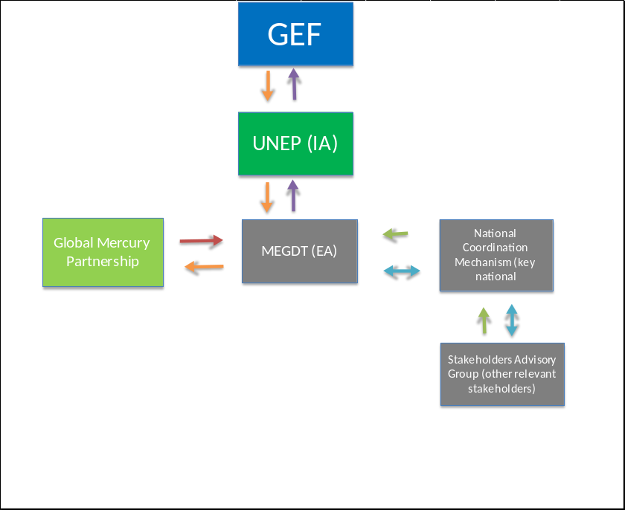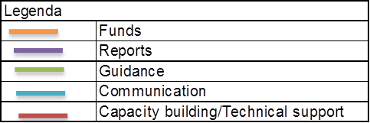
- Describe, if possible, the expected cost-effectiveness of the project:

The project will use the current capacity for chemicals management present in Mongolia, such as the existing infrastructure and coordination mechanisms. The project will also consider any previous efforts to collect information related to mercury uses and releases in the ASGM sectors in Mongolia.

The project will also take into account the expertise gathered by other countries in previous projects, and in turn, share the experiences and lessons learned with those countries that are at an early stage of NAP development. The project will coordinate closely with the Chemicals Division at UNEP and with the different mercury programmes and projects in place.

The integration of outcomes and deliverables of this project is also expected to provide significant input to the existing national framework for chemicals management in Mongolia. In this respect, enhanced capacities and knowledge on the uses and releases of mercury at the ASGM sector will facilitate the development and/or update of current policies and enforcement practices in a more efficient and resource saving approach.

- describe the budgeted M&E Plan:

Day-to-day management and monitoring of the project activities will be the responsibility of the executing agency. MEGDT will submit half-yearly progress reports and quarterly financial reports to the implementing agency at UNEP Chemicals. MEGDT will also be responsible for the issuing of legal documents such as agreements with the government and other institutions including recruitment of local/regional staff or consultants and the execution of the activities according to the work plan and expected outcomes.

The half-yearly and quarterly reports will include progress in implementation of the project, financial report, a work plan and expected expenditures for the next reporting period. It will also identify obstacles occurred during implementation period.

In consultation with UNEP Chemicals, MEGDT will identify suitable local consultants to assist in the development of the national inventory.

An independent terminal evaluation (TE) will take place at the end of project implementation, latest 6 months after completion of the project. The Evaluation Office of UNEP will be responsible for the TE and liaise with the UNEP Task Manager at DTIE Chemicals Branch throughout the process. The TE will provide an independent assessment of project performance (in terms of relevance, effectiveness and efficiency), and determine the likelihood of impact and sustainability. It will have two primary purposes: (i) to provide evidence of results to meet accountability requirements, and (ii) to promote learning, feedback, and knowledge sharing through results and lessons learned among UNEP and executing partners – MEGDT in particular. The direct costs of the evaluation will be charged against the project evaluation budget. The TE report will be sent to project stakeholders for comments. Formal comments on the report will be shared by the Evaluation Office in an open and transparent manner. Project performance will be assessed against standard evaluation criteria using a six point rating scheme. The final determination of project ratings will be made by the Evaluation Office when the evaluation report is finalised. The evaluation report will be publically disclosed and will be followed by a recommendation compliance process.

Table 4. Monitoring and Evaluation Budget
M&E activity | Purpose | Responsible  Party | Budget (US$)^{*1} | Time-frame
Inception workshop | Awareness raising, building stakeholder engagement, detailed work planning with key groups | MEGDT (Project Coordinator) | 0 | Within two months of project start
Inception report | Provides implementation plan for progress monitoring | MEGDT (Project Coordinator) | 0 | Immediately following Inception  Workshop
Technical Progress reports | Describes progress against annual work plan for the reporting period and provides activities planned for the next period | MEGDT (Project Coordinator) | 0 | Half yearly
Financial Progress reports | Documents project expenditure according to established project budget and allocations | MEGDT (Project Coordinator) | 0 | Quarterly
Project Review by  National Coordination Mechanisms | Assesses progress, effectiveness of operations and technical outputs; Recommends adaptation where necessary and confirms implementation plan. | MEGDT (Project Coordinator) | 0 | Month 2, 12 and 23
Terminal report | Reviews effectiveness against implementation plan.  Highlights technical outputs.  Identifies lessons learned and likely design approaches for future projects, assess the likelihood of achieving design outcomes. | MEGDT (Project Coordinator) | 0 | At the end of project implementation
Independent  Terminal evaluation | Reviews effectiveness, efficiency and timeliness of project implementation, coordination mechanisms and outputs.  Identifies lessons learned and likely remedial actions for future projects.  Highlights technical achievements and assesses against prevailing benchmarks | UNEP, Independent external consultant | 15,000 | At the end of project implementation
Independent Financial Audit | Reviews use of project funds against budget and assesses probity of expenditure and transactions | MEGDT (Project Coordinator) | 10,000 | At the end of project implementation
Total indicative M&E cost^{*1} |  |  | 25,000
*The inception workshop is one activity of the project component 2. Monitoring and evaluation activities will be done back to back with the inception workshop and therefore the cost is zero. The project Review by the National Coordination Committee will be held back to back with technical meetings that will take place throughout the project implementation. Therefore the additional cost is zero.

F. Explain the Deviations from typical Cost Ranges (where applicable):

part iii: approval/endorsement by gef operational focal point(s) and GEF agency(ies)

A. Record of Endorsement of GEF Operational Focal Point(s) on Behalf of the Government(s): (Please attach the Operational Focal Point endorsement letter(s) with this template).

Name | Position | Ministry | Date (Month, day, year)
B.Undarmaa | Senior Officer | Ministry of environment, green developnment and tourism | march, 07, 2016

B. Convention Participation
Convention | Date of Ratification/ Accession (mm/dd/yyyy) | National Focal Point
Minamata convention | Date Signed:  10/10/2013  Date Ratified:  28/09/2015 | National Focal Point:  T. Bulgan  Director, Green Development Policy And Strategic Planning Department, MEGDT | Date of Notification under Article 7 to the Minamata Convention Secretariat  07/03/2016

C. GEF Agency(ies) Certification
This request has been prepared in accordance with GEF policies and procedures and meets the standards of the GEF Project Review Criteria for Chemicals and Wastes Enabling Activity approval in GEF 6.
Agency Coordinator, Agency name | Signature | Date  (Month, day, year) | Project Contact Person | Telephone | E-mail Address
Brennan Van Dyke Director, UNEP GEF Coordination Office | 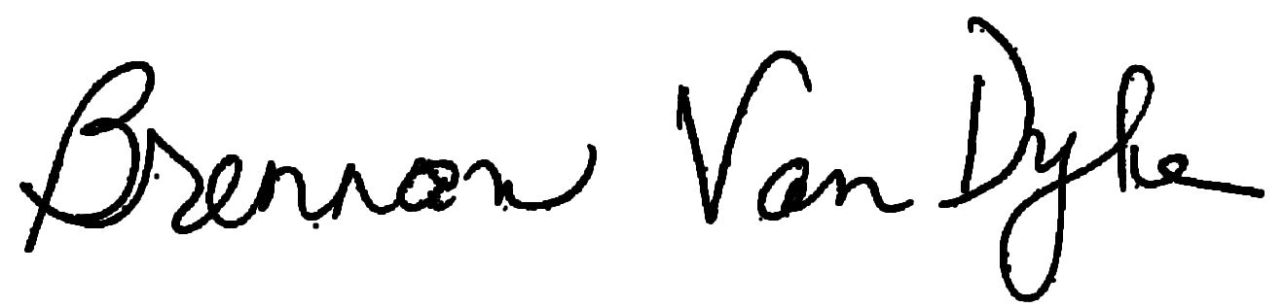 | June 27, 2016 | Kevin Helps  Senior Programme Officer  DTIE, UNEP | +254-20-762-3140 | Kevin.Helps@unep.org

Annexes:
- consultants to be hired for the Enabling Activity with gef Funding
- ofp endorsement letters and notification to the minamata secretariat
- environmental and social safeguards
- acronyms and abbreviations
- supervision plan
- gef approved budget

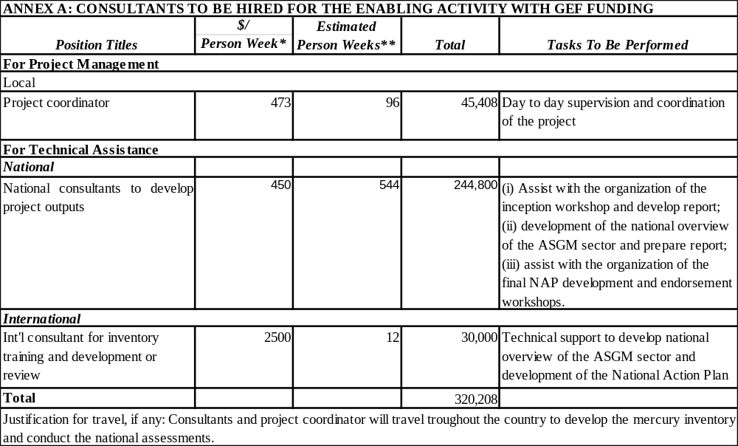
annex b: ofp endorsement letters and notification to the minamata secretariat

See attached documents

annex c: environmental and social safeguards checklist

As part of the GEFs evolving Fiduciary Standards that Implementing Agencies have to address ‘Environmental and Social Safeguards’. To fill this checklist:

- STEP 1: Initially assess E&S Safeguards as part of PIF development. The checklist is to be submitted for the CRC.
- STEP 2 : Check list is reviewed during PPG project preparation phase and updated as required
- STEP 3 : Final check list submitted for PRC showing what activities are being undertaken to address issues identified

UNEP/GEF Environmental and Social Safeguards Checklist

Project Title: | Development of National Action Plan for Artisanal and Small Scale Gold Mining in Mongolia
GEF project ID and UNEP ID/IMIS Number |  | Version of checklist
Project status (preparation, implementation, MTE/MTR, TE) | Preparation/ Submission | Date of this version: | 17/06/2016
Checklist prepared by (Name, Title, and Institution) | Kevin Helps – Senior Programme Officer  GEF Operations - UNEP DTIE Chemicals

In completing the checklist both short- and long-term impact shall be considered.

Section A: Project location
If negative impact is identified or anticipated the Comment/Explanation field needs to include: Project stage for addressing the issue; Responsibility for addressing the issue; Budget implications, and other comments.

 | Yes/No/N.A. | Comment/explanation
- Is the project area in or close to -
- densely populated area | N.A: | The project will assess the situation with regard to mercury use in the ASGM sector and related emissions and releases across Mongolia. It will not take direct action on the ground but inventories prepared to address priority issues will take socio-economic and environmental considerations into account.
- cultural heritage site | N.A:
- protected area | N.A:
- wetland | N.A:
- mangrove | N.A:
- estuarine | N.A:
- buffer zone of protected area | N.A:
- special area for protection of biodiversity | N.A:
-will project require temporary or permanent support facilities? | N.A:
If the project is anticipated to impact any of the above areas an Environmental Survey will be needed to determine if the project is in conflict with the protection of the area or if it will cause significant disturbance to the area.

Section B: Environmental impacts
If negative impact is identified or anticipated the Comment/Explanation field needs to include: Project stage for addressing the issue; Responsibility for addressing the issue; Budget implications, and other comments.

 | Yes/No/N.A. | Comment/explanation
- Are ecosystems related to project fragile or degraded? | N.A. | The project will assess the situation with regard to mercury use in the ASGM sector and related emissions and releases in Mongolia. It will not take direct action on the ground but assessments and the national overview of the ASGM sector will assist Mongolia to identify priority issues in relation to human health and the environment, where socio-economic and environmental considerations will be identified.
- Will project cause any loss of precious ecology, ecological, and economic functions due to construction of infrastructure? | No
- Will project cause impairment of ecological opportunities? | No
- Will project cause increase in peak and flood flows? (including from temporary or permanent waste waters) | No
- Will project cause air, soil or water pollution? | No
- Will project cause soil erosion and siltation? | No
- Will project cause increased waste production? | No
- Will project cause Hazardous Waste production? | No
- Will project cause threat to local ecosystems due to invasive species? | No
- Will project cause Greenhouse Gas Emissions? | No
- Other environmental issues, e.g. noise and traffic | No
Only if it can be carefully justified that any negative impact from the project can be avoided or mitigated satisfactorily both in the short and long-term, can the project go ahead.

Section C: Social impacts
If negative impact is identified or anticipated the Comment/Explanation field needs to include: Project stage for addressing the issue; Responsibility for addressing the issue; Budget implications, and other comments.

 | Yes/No/N.A. | Comment/explanation
- Does the project respect internationally proclaimed human rights including dignity, cultural property and uniqueness and rights of indigenous people? | Yes | It will respect cultural aspects of Mongolia.
- Are property rights on resources such as land tenure recognized by the existing laws in affected countries? | N.A.
- Will the project cause social problems and conflicts related to land tenure and access to resources? | No | The participation of stakeholders involved in the ASGM activity in the national advisory group will ensure social problems and conflicts related to access to gold will be avoided.
- Does the project incorporate measures to allow affected stakeholders’ information and consultation? | Yes | The project will form National Coordination Committees and a National Advisory Groups including all relevant stakeholders. These groups will assess project progress at the national level and will propose if necessary corrective actions. Additionally, the Project Executing Agency will provide technical feedback and assistance to Mongolia.
- Will the project affect the state of the targeted country’s (-ies’) institutional context? | Yes | In the medium to long-term it is expected that the national regulatory system will be revised to include provisions in compliance with the Minamata Convention, in particular article 7.
- Will the project cause change to beneficial uses of land or resources? (incl. loss of downstream beneficial uses (water supply or fisheries)? | No
- Will the project cause technology or land use modification that may change present social and economic activities? | Yes | The NAPs will look for the deep causes of mercury use in the ASGM activity in Mongolia and suggest alternatives to current practices towards the sound management of mercury.
- Will the project cause dislocation or involuntary resettlement of people? | No
- Will the project cause uncontrolled in-migration (short- and long-term) with opening of roads to areas and possible overloading of social infrastructure? | No | The NAPs will consider the potential negative impacts of policies to reduce mercury use in the ASGM sector as uncontrolled migration. The purpose of the NAPs is to identify alternatives to mercury use and not impair livelihoods.
- Will the project cause increased local or regional unemployment? | No | The NAPs will consider the potential negative impacts of policies to reduce mercury use in the ASGM sector as increased local unemployment. The purpose of the NAPs is to identify alternatives to mercury use and not impair livelihoods.
- Does the project include measures to avoid forced or child labour? | No
- Does the project include measures to ensure a safe and healthy working environment for workers employed as part of the project? | Yes | Those doing the inventory on the field will use protective equipment to avoid contamination with those chemicals.
- Will the project cause impairment of recreational opportunities? | No
- Will the project cause impairment of indigenous people’s livelihoods or belief systems? | No | The NAPs will consider the potential negative impacts of policies to reduce mercury use in the ASGM sector as impairment of indigenous people’s livelihoods. The purpose of the NAPs is to identify alternatives to mercury use and not impair livelihoods.
- Will the project cause disproportionate impact to women or other disadvantaged or vulnerable groups? | No | The NAPs will consider in particular the potential negative impacts of policies to reduce mercury use in the ASGM sector to women and other disadvantaged or vulnerable groups.
- Will the project involve and or be complicit in the alteration, damage or removal of any critical cultural heritage? | No
- Does the project include measures to avoid corruption? | Yes | Close supervision of the expenditures will be done at the national level by the EA and overall by UNEP as IA. Cash advances will be related to outputs and held until proper justification of the expenditures and budget plans are provided.
Only if it can be carefully justified that any negative impact from the project can be avoided or mitigated satisfactorily both in the short and long-term, can the project go ahead.

Section D: Other considerations
If negative impact is identified or anticipated the Comment/Explanation field needs to include: Project stage for addressing the issue; Responsibility for addressing the issue; Budget implications, and other comments.

 | Yes/No/N.A. | Comment/explanation
- Does national regulation in affected country (-ies) require EIA and/or ESIA for this type of activity? | No
- Is there national capacity to ensure a sound implementation of EIA and/or SIA requirements present in affected country (-ies)? | N.A.
- Is the project addressing issues, which are already addressed by other alternative approaches and projects? | No
- Will the project components generate or contribute to cumulative or long-term environmental or social impacts? | No | No negative impacts
- Is it possible to isolate the impact from this project to monitor E&S impact? | N.A.

annex d. acronyms and abbreviations

ASGM | Artisanal and Small-Scale Gold Mining
ASM | Artisanal and Small-Scale Mining
BRS | Basel, Rotterdam and Stockholm Conventions
DTIE | Division of Technology Industry and Economics
EA | Executing Agency
ESECI | Engaging Stakeholders in Environmental Conservation
GEF | Global Environment Facility
GEF SEC | Global Environment Facility Secretariat
GEF TF | Global Environment facility Trust Fund
GMP | Global Mercury Partnership
HRBA | Human Rights Based ASM
IA | Implementing Agency
INC | Intergovernmental Negotiating Committee
M&E | Monitoring and Evaluation
MEAs | Multilateral Environmental Agreements
MEGDT | Ministry of Environment, Green Development and Tourism of Mongolia
MIA | Minamata Initial Assessment
MRAM | Mineral Resource Authority of Mongolia
NA | Non applicable
NAP | National Action Plan
NCM | National Coordination Mechanism
NGOs | Non-governmental Organizations
OFP | Operational Focal Point
OHS | Occupational Health and Safety
PMC | Project Management Cost
PoW | Programme of Work
PPG | Project Preparation Grant
PSC | Project Steering Committee
ROAP | Regional Office for Asia and Pacific
SAG | Stakeholder Advisory Group
SAICM | Strategic Approach for International Chemicals Management
SAM | Sustainable Artisanal Mining
SDC | Swiss Agency for Development and Cooperation
SDGs | Sustainable Development Goals
TE | Terminal Evaluation
UN | United Nations
UNEA | United Nations Environmental Assembly
UNEP | United Nations Environment Programme
UNITAR | United Nations Institute for Training and Research
WHO | World Health Organization

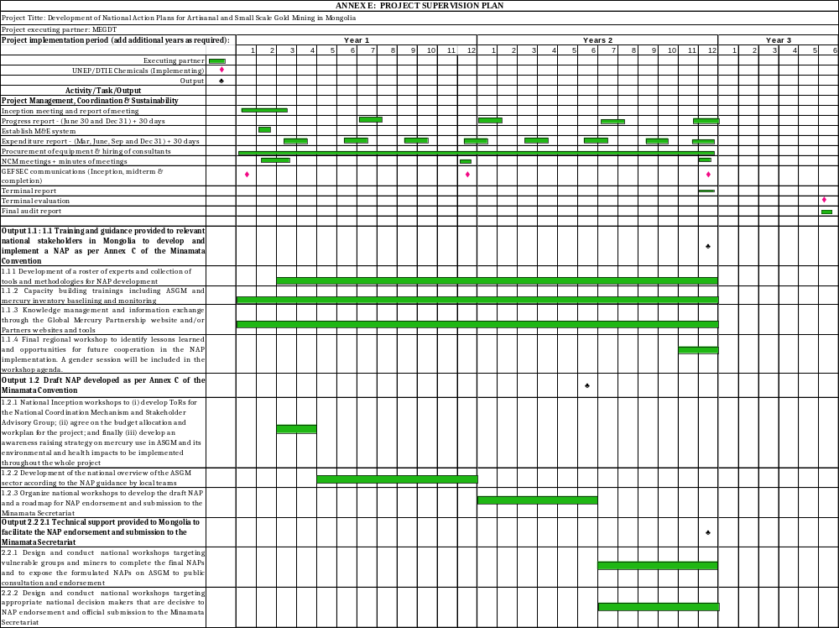

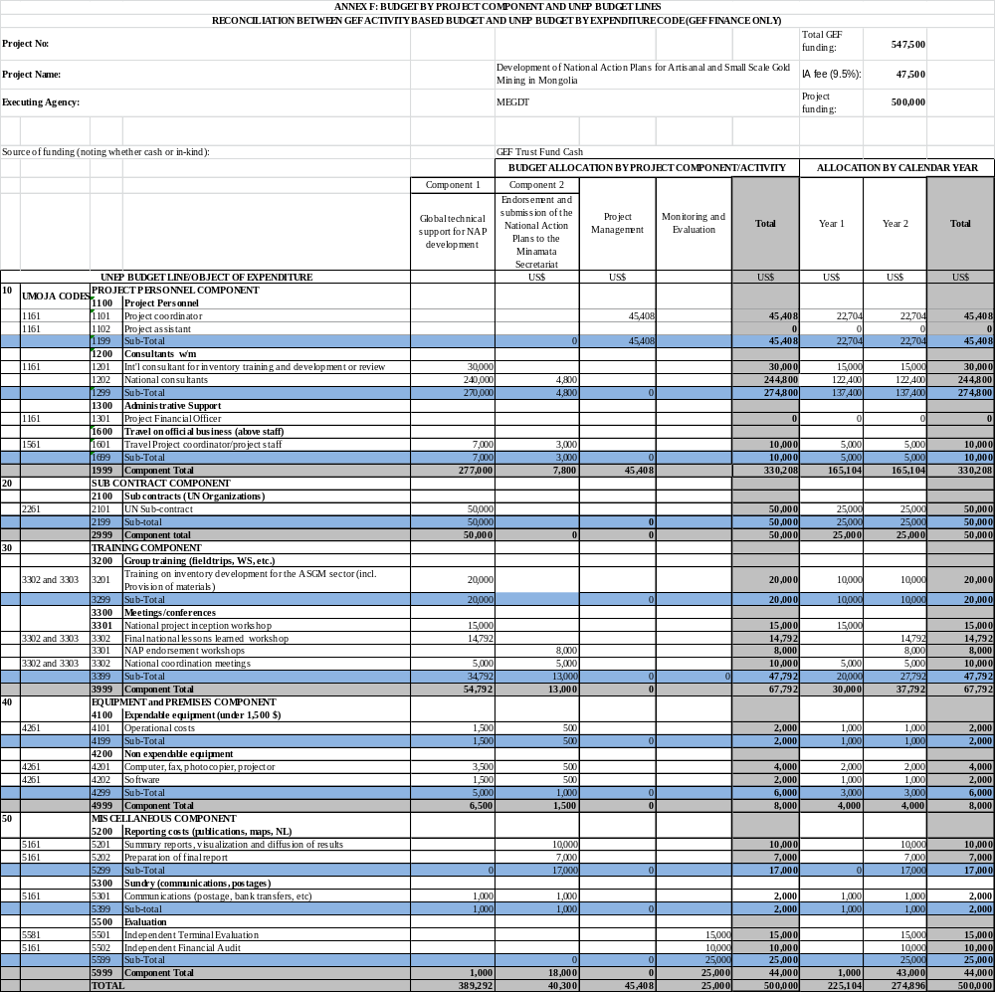

Project ID number will be assigned by GEFSEC and to be entered by Agency in subsequent document submission.
Co-financing for enabling activity is encouraged but not required.
This is the cost associated with the unit executing the project on the ground and could be financed out of trust fund or co-financing sources. For EAs within the ceiling, PMC could be up to 10% of the Subtotal GEF Project Financing.
T. Navch, Ts. Bolormaa, B. Enkhtsetseg, D. Khurelmaa, B. Munkhjargal: Informal Gold Mining in Mongolia. ILO 2006. (http://www.unescap.org/stat/isie/reference-materials/Analysis-Country-Documents/Informal-gold-mining-MNG.pdf)
http://www.amap.no/documents/doc/technical-background-report-for-the-global-mercury-assessment-2013/848.
Class 1 = presence/absence, no quantitative information, error can be greater than 100% (25 countries); class 2 = some indication of quantity of Hg used, estimated average error 75% (20 countries); class 3 = quantitative data but not significantly updated within past five years, error 50%(17 countries); class 4 = recent quantitative data; error 30%; b emission factor for concentrate amalgamation = 0.75 (1/1.3); Emission factor for whole ore amalgamation = 0.25 (1/4).
Guidance Document: Developing a National Strategic Plan to Reduce Mercury Use in Artisanal and Small-Scale Gold Mining, available at http://www.mercuryconvention.org/Portals/11/documents/meetings/inc7/English/7_17_e_ASGM.pdf.
Ibid.
http://www.wecf.eu/english/articles/2013/10/minamata-sideevent.php
See Telmer and Veiga (2009)
See United States EPA (1997); Bose-O’Reilly et al. (2010)
GEF policies encompass all managed trust funds, namely: GEFTF, LDCF, and SCCF

